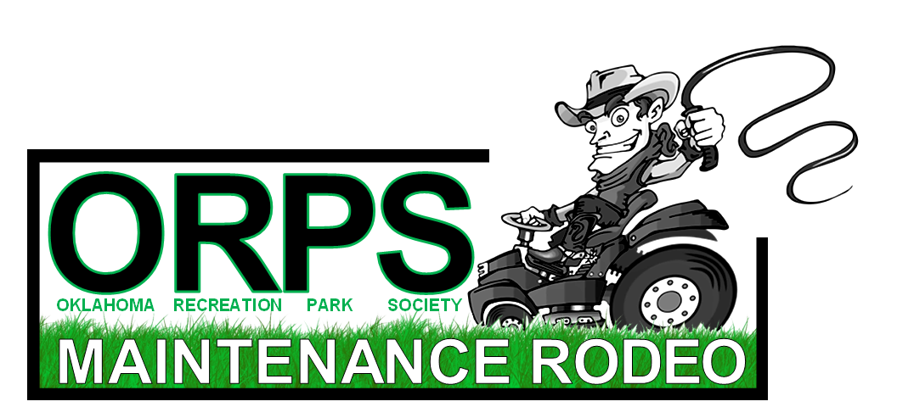

Thursday ~ November 04, 2021 Joe B Barnes Regional Park
8:00 - 8:45am Check-In/Breakfast 8700 East Reno ~ Midwest City, OK 73011
9:00am - 12:00pm Rodeo Activites
12:00 - 1:00pm Lunch by P&K Equipment
1:00 - 3:00pm Rodeo Wrap Up/Awards

Are you ready for the ORPS Equipment Maintenance Rodeo? You won’t be riding bulls or roping cattle, but you will be showing off the skills you have gained in the field. We know you’ve said it before…
“my crew can mow faster than your crew”
“do I need to back that trailer for you”
“seriously, how long does it take to change an irrigation head”
See if you’ve got what it takes to be the best in the state!

Please provide the name of a participant for each event in which your City will participate. Your City can enter multiple teams, however participants are limited to 1 team and cannot transfer to another team. Cost is $250 per team.
Maintenance Rodeo rules and details are provided on the following pages.

The deadline for registration is Friday ~ October 29, 2021.

City Name:
Contact Name:
Contact Phone:
E-Mail:

EVENT | PARTICIPANT NAME | PARTICIPANT  NAME
Trailer Obstacle Course
(2 participants)
Irrigation Assembly
(2 participants)
Plant/Weed Identification
(1 participant)
Nail Driving Contest
(1 participant)
ZTR Mower Obstacle Course
(1 participant)
Backpack Blower Course
(1 participant)
Backhoe Operation Contest
(1 participant)

Please mail or email completed form to:
Jeff Edwards – ORPS Maintenance Rodeo
1050 West Wekiwa Road ~ Sand Springs, OK 74063
Phone: (918) 246-2562 Email: jeff@sandspringsok.org

ORPS Maintenance Rodeo
2021 State Rodeo Rules

- State Maintenance Rodeo is to be held at the annual OPRS Conference and Trade show.
- The state rodeo will consist of seven events: Truck & Trailer Competition, Zero Turn Mower Obstacle Course, Backhoe Competition, Blower Competition, Irrigation Assembly, Nail Drive Competition, and Plant Identification.
- Strict adherence to safety is a must and any contestant that engages in dangerous operation of a piece of equipment or horseplay will be disqualified from the competition and all points forfeited. Each of the judges overseeing the equipment events will have whistles that will be used to control the events and maintain safety. All contestants upon hearing a whistle will be required to immediately stop the operation of the equipment and await instructions from the judge.
- The State Rodeo will be scored as follows: 5 points for first place, 4 points for second place, 3 points for third place, 2 points for fourth place, and 1 point for fifth place. Awards will be given for the first three places.
- The City that accrues the most points during the competition will be declared the State Champion. Awards will be given to the second and third place overall.
- If at the end of the competition a tie exists for the State Champion, the Chairman of the committee will randomly draw a card with the name of the one of the seven events: Truck and Trailer Competition, Zero Turn Mower Obstacle Course, Backhoe Competition, Irrigation Assembly, Nail Drive Competition, and Plant Identification. The City(s) will then be required to compete in that one category again and the City that wins the event becomes the State Champion.
Truck & Trailer Course
- This event consists of a team of two people; a driver and a backup guide
- The course setup consists of one truck and trailer stall
- One half-ton truck and one 8-foot wide by 18-foot long trailer will be used.
- The object is to
  - Remove wheel chocks and put them on the trailer
  - Pull out and complete the course and back the truck and trailer into the original start position and chock the wheels.
- Challenges- The object of the tennis ball is to force contestants to operate the vehicle in a very careful and deliberate manner to maximize safety even though this is a timed event.
- Penalties will be assessed for each tennis ball knocked from its perch.
  - Thirteen cones will be placed along the sides and back of the stall exactly 6 inches from the widest point of the trailer (typically the fender wells) with a tennis ball balanced on top.
  - A traffic cone will be placed in the center of the trailer with a tennis ball balanced in top.
- Procedure: Seat belts must be worn at all times when the vehicle is in motion, failure to do so will result in disqualification.
  - Guide
    - When the whistle blows to start the event, the guide must remove his seat belt, exit the truck, remove the chocks, get in the truck, fasten his seatbelt and remain in the truck until the driver has come to a complete stop and is ready to begin backing up into the stall.
    - The backup guide will be allowed out of the truck only when the truck and trailer is within 8 feet of the stall (there will be an indicator stripe 8 feet in front of the stall for this purpose).
    - When the guide stops the driver in the stall he/she shall replace the wheel chocks to complete the run.
  - Driver
    - The driver must stay in the vehicle at all times.
    - The truck and trailer must be backed into the stall to a depth in which the front of the bumper of the truck clears the base of the front of the cone. This will leave the rear of the trailer 2 feet from the rear of the cone.
    - The driver can then choose to go for the bonus points by attempting to pull within 6 inches of the rear of the cone without touching it.
- Timing
  - Time starts when the judge blows the whistle and ends when the truck and trailer are returned to the starting position, the transmission placed in park, the engine is turned off, and the wheels are chocked.
  - Time limit for this event is 3 minutes.

Scoring
- Total time from start to finish in seconds.
- For a bonus subtract 30 seconds for a perfect run in which no tennis balls were knocked off, also subtract 30 seconds for getting the trailer within 6 inches of the back stanchion without toughing it.
- Team with the lowest final time is the winner.
Penalties
- Add 30- second penalty for each tennis ball knocked off a stall stanchion.
- Add 60- second penalty for knocking off trailer tennis ball.
- Disqualification for spinning tires on truck.
- Disqualification for not wearing seatbelt when vehicle is in motion.
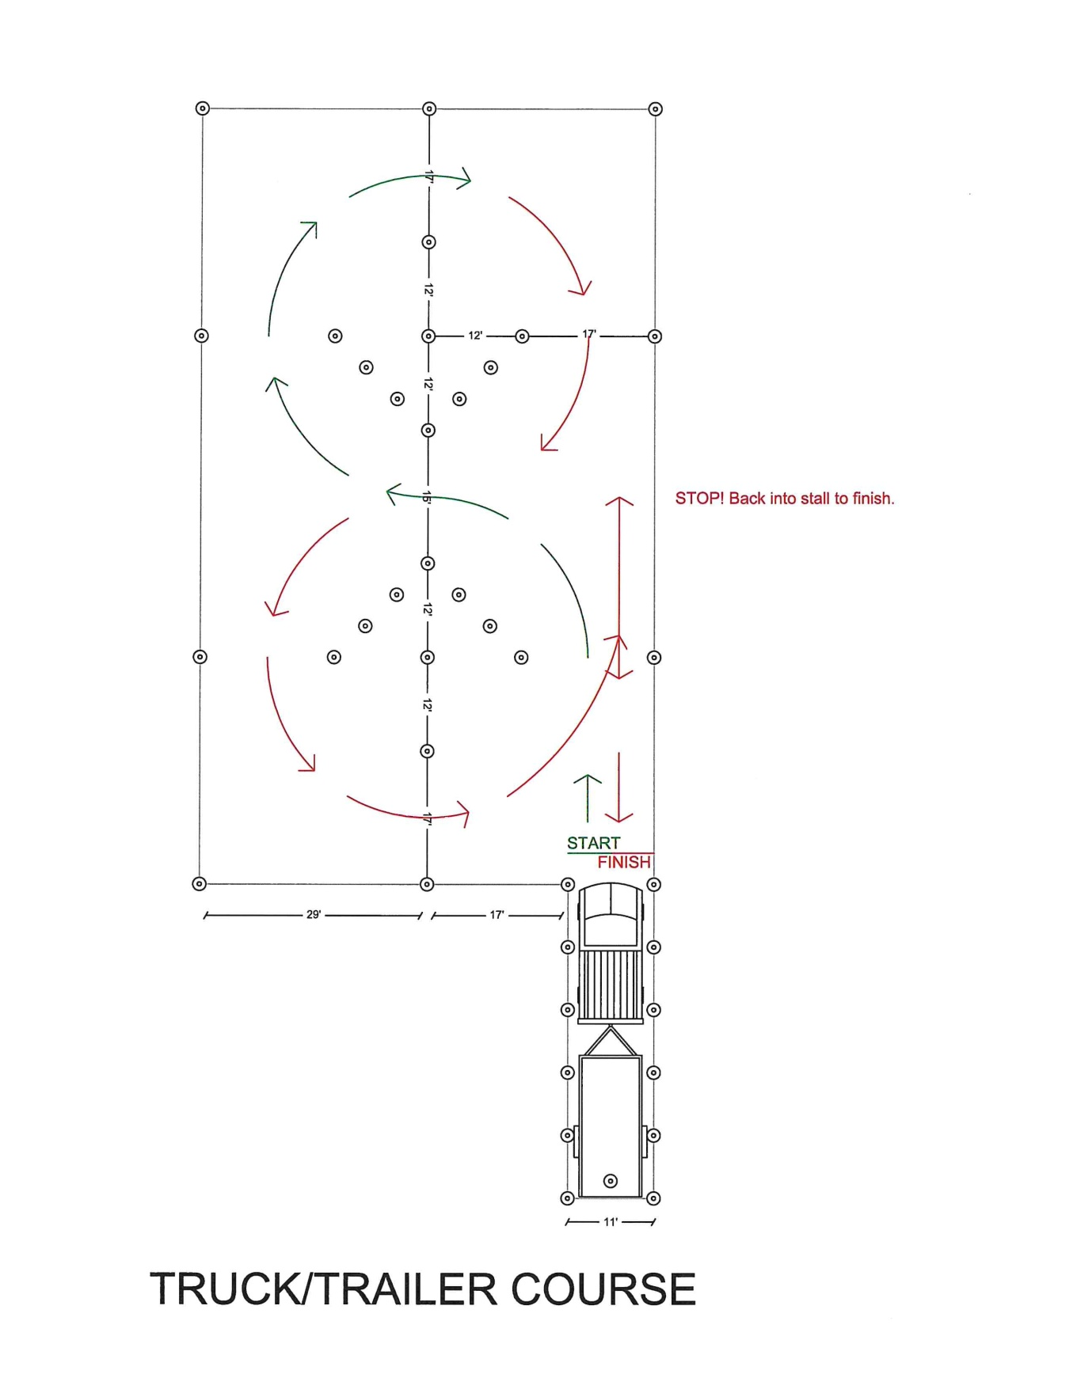

Zero Turn Mower Obstacle Course Rules
- The object is to
  - Follow the directions given, circling the obstacles to the operator’s left on the way down to the table which is to be circled clockwise and circling the obstacles to the operators right on the return.
  - Conclude pulling headfirst into the parking stall on the operators left and backing out and returning mower to the start position.
- Seat belts must be worn at all times when the mower is in motion, failure to do so will result in disqualification.
- Challenges
  - Tennis balls will be placed on the top of the cones to help judges determines when the contestant has struck a cone.
  - The judges will attempt to reset any tennis balls that are knocked off during a run.
  - If they cannot reset the ball during the run, judges will monitor the cone for further contact and assess penalties as needed.
  - The cones on the outside perimeter of the course are considered “out of bounds indicators” and a 30 second penalty will be assessed for every ball knocked off.
  - A ball will also be placed on the top of a coffee can on top of the table. If this ball falls off the can that will indicate that the contestant has “run over” the table and he/she will be disqualified.
  - Trash cans will be placed upside down in the center of the course. Tennis balls will be placed on a PVC fitting on top of each barrel to serve as a “contact” indicator. If a tennis ball is knocked of a PVC fitting, it will count as a 60 second penalty.
  - Dimensions for the obstacles will be 5” per side wider than the widest point of the widest mower used.
- Timing
  - Time will start at the whistle and will end when the operator sets the parking brake and turns the machine off.
Scoring
- Total elapsed time from start to finish in seconds.
- For a bonus, subtract 30 seconds for a perfect run in which no cones or obstacles are hit; add any penalty time to determine final adjusted time score.
- Person with fastest final time is the winner.
Penalties
- Add 30 second penalty for each tennis ball knocked off a “out of bounds” cone.
- Add 60 second penalty for “contacting” an obstacle.
- Disqualification for not following prescribed course in the directions indicated.
- Disqualification for running over cones or obstacles. This will be determined by knocking the ball off the can on the table, knocking over a trashcan, or knocking over or driving over a cone.

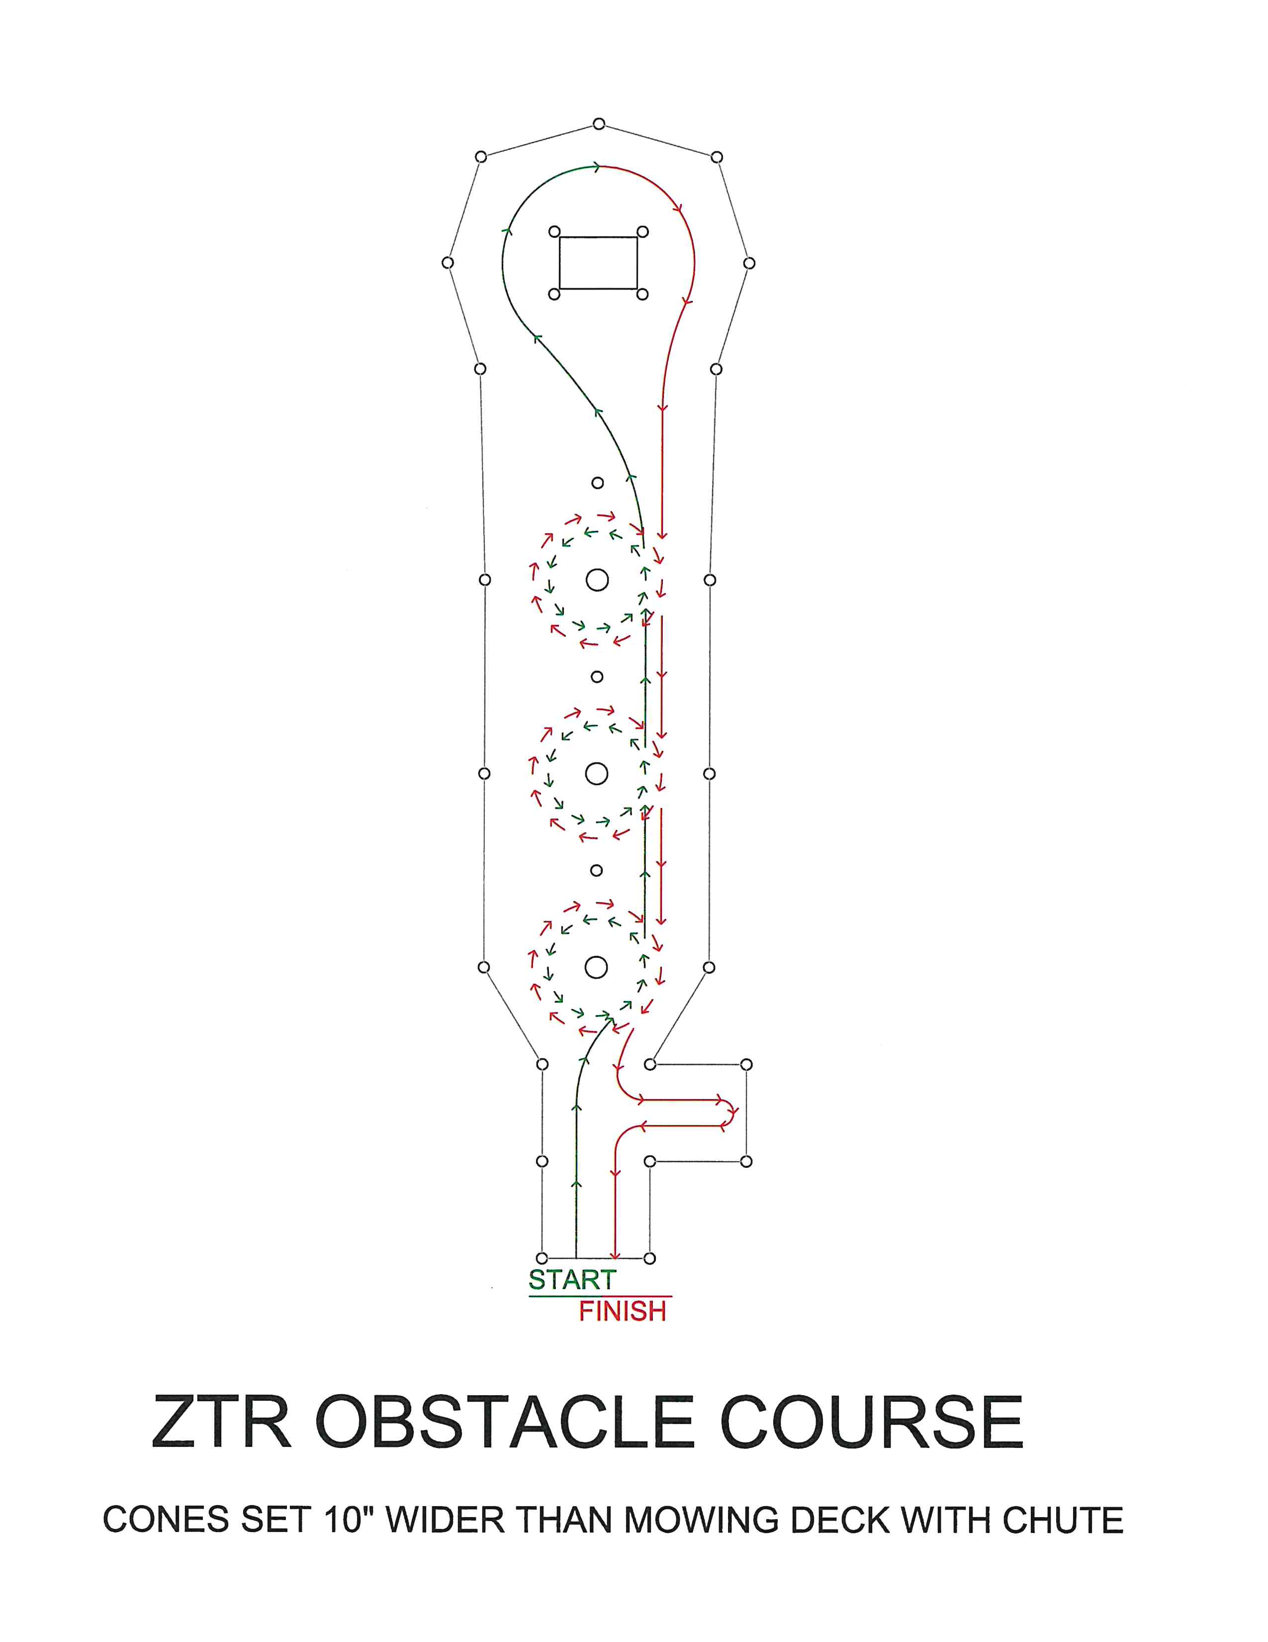
Backhoe/Trackhoe Competition Rules
For safety purposes: A radius line is to be clearly drawn beyond the reach of the backhoe bucket. A judge, finding any contestant or team member inside that line before or during the event when the backhoe is running, will disqualify that team from the backhoe event.

The contest will consist of picking up three kettle bells, a 10#, 20#, and 30#, and attempting to place each one inside a color coded circle that matches the kettle bell and returning the bucket back to the starting point.

The three kettle bells shall be placed in the front of the backhoe in a starting position that is located so the tractor can easily pick up each kettle bell. The backhoe bucket shall be fully curled in the normal transport position. Each kettle bell will have a circle to be placed in based on color. The circle in which the kettle bell is to be placed shall have a radius 3” longer that the height of the standing kettle bell so that the handle of the kettle bell is centered, yet having fallen over can fit within the diameter of the circle. The locations of stands shall be marked clearly so they can be relocated in the same position for each contestant.

Each contestant will be allowed to operate the equipment in a normal fashion (extending, curling, and swinging) without touching the kettle bells for one minute to get a feel for the equipment. After returning the equipment to the start position and both hands are removed from the controls, the judge will blow the whistle and start the time. The contestant will attempt to pick up each kettle bell from the starting position and place them on the color coded target and return the equipment to the start position. The judge will record the time with a stop watch. Time starts at the whistle and ends when the operator returns the equipment to the start position and removes his/her hands from the controls.

All three kettle bells must be completely inside the color coded circles in order for the score to count. If any part of any kettle bell is on or over the line the contestant will be disqualified.
Scoring
- Total time from start to finish in seconds: Add twenty seconds for any kettle bell that falls over yet remains inside the color coded circle to determine a final adjusted time score. The person with the lowest final time is the winner.
Penalties
- Add 20 seconds for any keg ball that falls over yet remains inside the painted circle.
- Disqualification for placing any part of a keg ball outside the painted circle.
- Disqualification for any damage to or knocking over the barrel.

Nail Drive Contest Rules
- A 24- ounce framing hammer will be used to drive a 20d bright common nail into a 2x6 pine plank.
- The object is to use the fewest number of hits to drive the nail fully into the wood.
- Procedure:
  - Contestants will enter the safety area and dress in safety equipment provided (A face shield and jacket).
  - A nail will already be started in the wood to a predetermined depth. Using the 24- ounce framing hammer, the contestant may strike the nail as many times as necessary to bury the nail of the head into the wood.
  - Every touch of the hammer to the nail or wood (in case of a miss) counts as a strike.
  - The contestant isn’t allowed to touch the nail with his/her hands to straighten it or otherwise. They may however touch the board.
  - The contestant is allowed to kneel.
  - A contestant will not be allowed to start over if they bend the nail.
  - Only fully driven nails count.
  - Practice taps at the beginning count towards the strike if they touch the nail.
Scoring
- Fewest number of hits required to drive the nail completely into the wood is declared the winner.
Penalties
- Disqualification for bending nail to extent it cannot be driven flush.
- No score for any nail not driven flush to the head. Any nail head that a playing card can be slipped under is not flush.

Landscape Blower Competition
- The object is to:
- Use air from a blower to force a tennis ball through openings created by metal hoops in the quickest time.
- Procedure:
- The participant will begin at the start line and use air to force the ball through the opening along the route indicated.
- The ball must pass through the openings in the correct order and direction as indicated.
- Equipment:
- The blower must be worn/ used as described in owner’s manual.
- Hearing protection must be worn.
- The standard straight extensions will be placed on the blower and must remain on during contest.
- No additional attachments will be allowed on the hose or the blower other that what is provided.
- Timing:
- The time starts at the whistle and ends when the ball crosses the finish line.
Scoring
- This is a simply a race against time. The fastest elapsed time wins.
Penalties
- Disqualification for touching ball by contestant or equipment.
- Disqualification for ball going out of bounds.

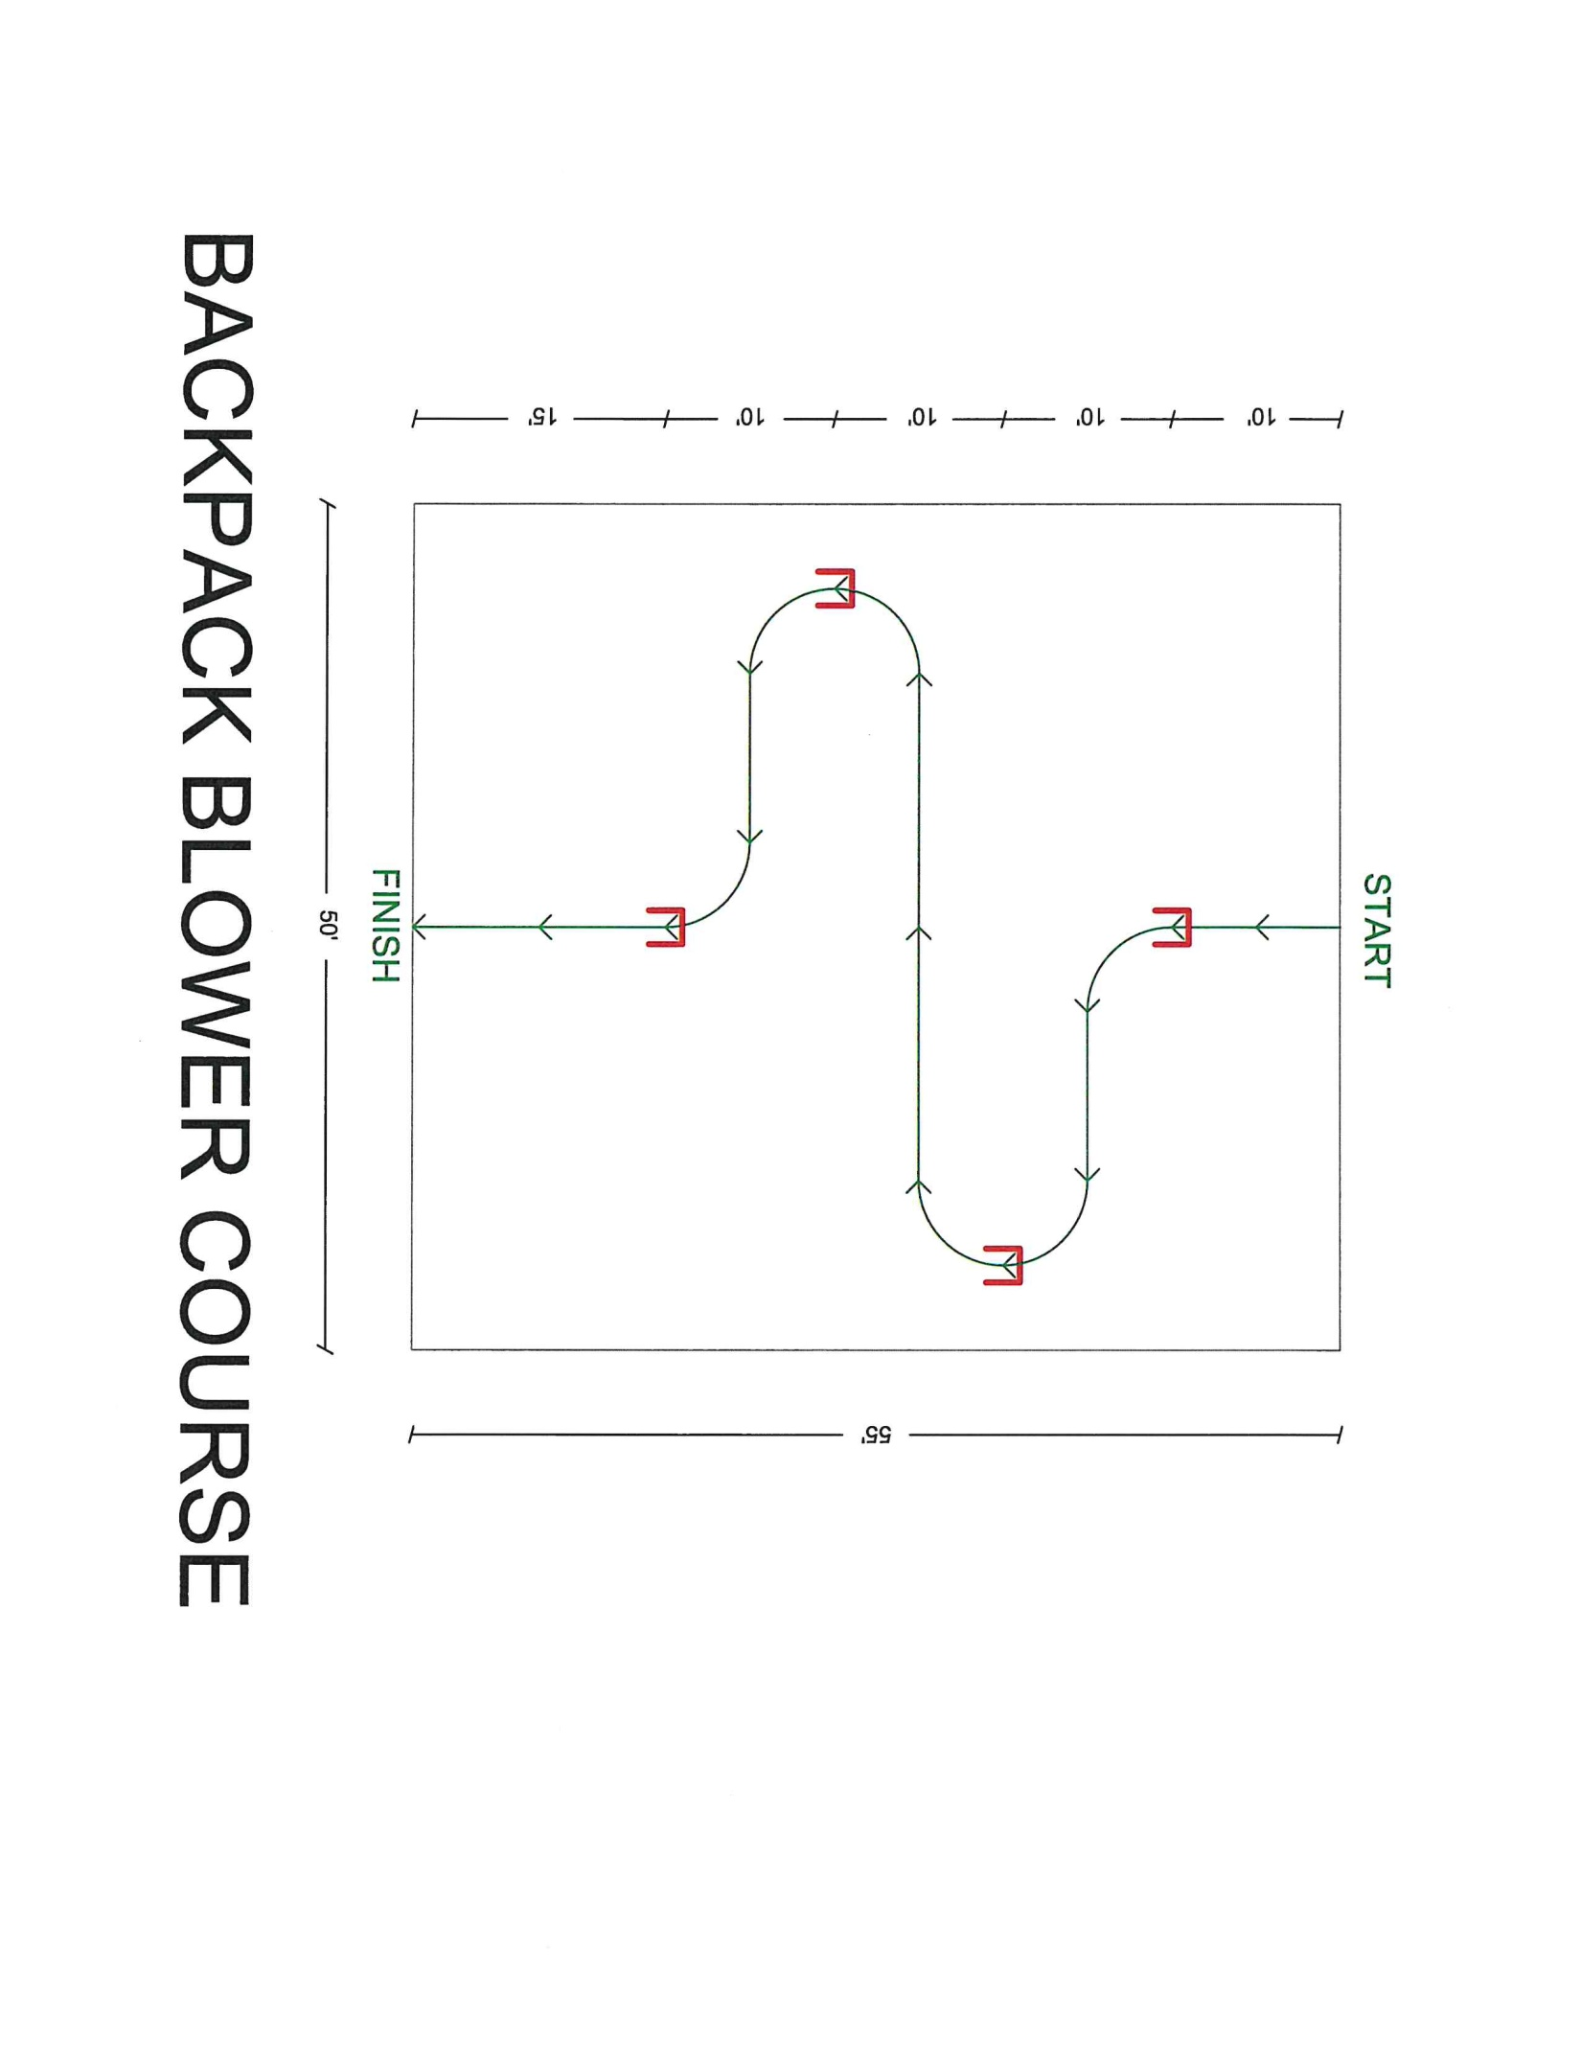
Plant and Weed Identification
- To prevent any preview by contestant, test packets will remain sealed with committee chair until the contest begins.
- The object is:
- To correctly identify a total of 10 plants; 5 weeds and 5 trees.
- The reference for this competition will be
Know It and Grow It: A Guide to the Identification and Use of Landscape Plants
- Procedure:
- Each contestant will be given a test packet and pencil on a clip board.
- No discussion will be allowed during the test.
- Contestant will write down the common name of each plant on line provided.
- Contestant will write the scientific name of the plant on the line provided.
- Once finished the contestant will turn test and clipboard back into the judge.
- Contestants will leave testing area after turning in test.
- Timing
- The judges will announce when to start the test. No opening of packet until advised by the judge.
- The test will have a maximum time of 15minutes.
Scoring
- 10 points will be awarded for each common name correctly identified for a total possible score of 100.
- 10 bonus points will be awarded for each scientific name correctly identified.
- Note: Minor spelling errors will be overlooked, however if spelling errors or handwriting are such that the judges cannot readily identify the answer it will be marked incorrect. In the event of a tiebreaker spelling WILL count and if the scientific name is not spelled correctly it will not count as bonus.

Irrigation Assembly
- This event consists of two people.
- Teams will compete side by side and as soon as a team completes their assembly they will turn the station on with live water.
- All materials will be provided at the start area.
- All assembly points will be threaded and no penalty will be deducted for minor leaks since all connections will the threaded together without any sealant.
- Each team will be allowed 5 minutes to organize the parts and pipes in the starting area.
- Procedure
- Speed and accuracy are equally important in this event because of penalty times being assessed for not correctly assembling the system or properly adjusting the heads as specified in the attached drawing.
- Each team will be given a set of plans.
- Hunter I20 adjustable rotor heads preset to 360 will be used. Nozzles will be preinstalled.
- All the parts in the kit will be used.
- If a part breaks accidently that prevents completion of the event, at the judge’s discretion, the team may be allowed to compete in another heat.
- Timing
- Time will start at the first whistle and assembly will begin at second whistle, time will start when both members of the team cross the finish line and turn on water.
- The team that turns their water on first may not necessarily have the fastest final time score.
Scoring
- Total elapsed time from start to finish in seconds; add any penalty time to obtain final adjusted time score.
- Team with the fastest time will be the winner.
Penalties
- Add 10 seconds for each head not adjusted properly.
- Add 10 seconds for each head that falls to the ground when water is turned on.
- Disqualification if poor assembly results in major water leak.
- Disqualification if system doesn’t follow specified lay out.
